>>AWS Load Balancer – Brief & Easy Notes
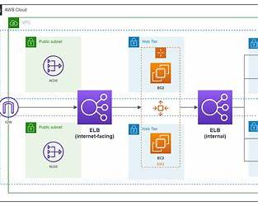
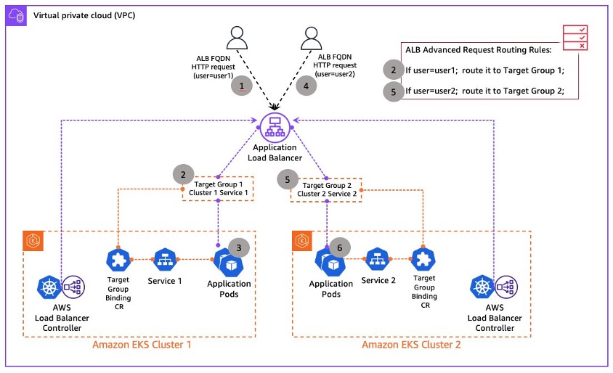
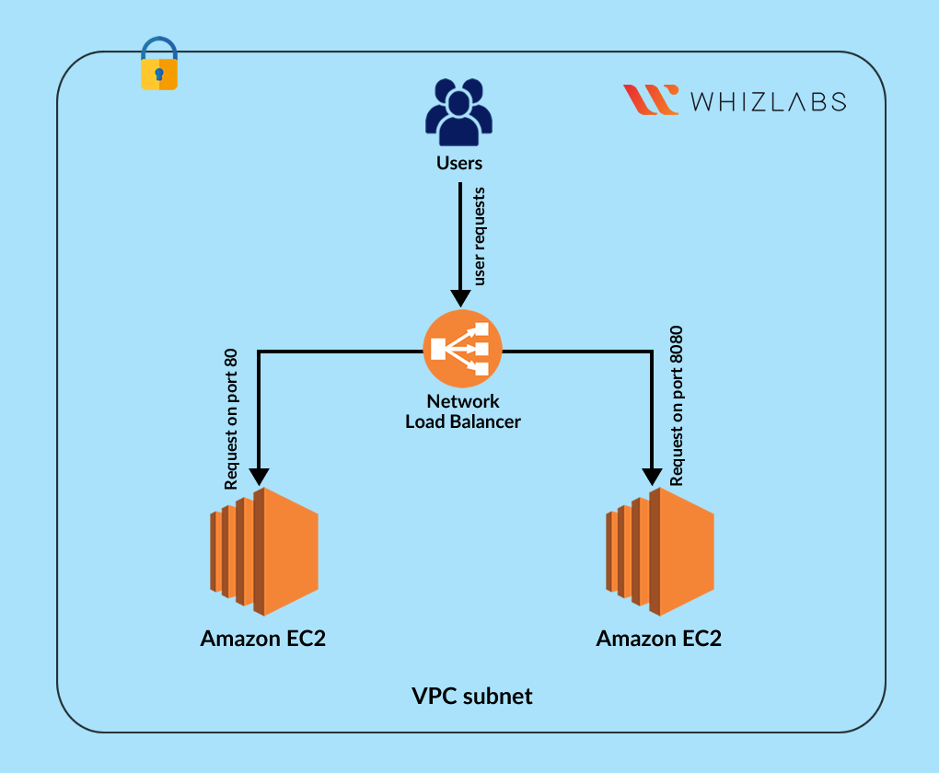
4

What is Elastic Load Balancing (ELB)?
AWS Load Balancer automatically distributes incoming traffic across multiple servers (EC2, containers, IPs) to ensure:
- High availability
- Better performance
- Fault tolerance
👉 Simple meaning:
It prevents one server from getting overloaded.

🔹 Types of AWS Load Balancers

1️⃣ Application Load Balancer (ALB)
- Works at Layer 7 (HTTP/HTTPS)
- Used for web applications
✔ Path-based routing (/login, /api)
✔ Host-based routing
✔ Supports containers & microservices
📌 Best for: Web apps, APIs

2️⃣ Network Load Balancer (NLB)
- Works at Layer 4 (TCP/UDP)
- Handles very high traffic
- Extremely low latency
✔ Static IP support
✔ Millions of requests/sec
📌 Best for: Real-time apps, gaming, VoIP

3️⃣ Gateway Load Balancer (GWLB)
- Used for security appliances
- Traffic inspection (firewalls, IDS/IPS)
📌 Best for: Network security solutions

4️⃣ Classic Load Balancer (CLB) (Legacy)
- Layer 4 & Layer 7
- Not recommended for new apps

🔹 Core Components of Load Balancer

🔸 Listener
- Checks port & protocol
- Example: HTTP 80, HTTPS 443

🔸 Target Group
- Group of backend servers
- Targets:
  - Amazon EC2
  - IP addresses
  - Containers

🔸 Health Checks
- Checks server health
- Sends traffic only to healthy targets

🔹 How Load Balancer Works (Simple Flow)
- User sends request
- Load Balancer receives traffic
- Health check verifies targets
- Traffic forwarded to healthy server
- Response sent back to user

🔹 High Availability & Fault Tolerance
- Load balancers work across multiple Availability Zones
- Automatically reroutes traffic if one AZ fails

🔹 Security Features
- Works with Security Groups
- SSL/TLS termination
- Integrates with AWS Certificate Manager
- Supports AWS WAF

🔹 Load Balancer Algorithms
- Round Robin (default)
- Least outstanding requests (ALB)
- Flow hash (NLB)

🔹 Pricing (Simple)
You pay for:
- Load balancer hours
- Data processed (LCU / NLCU)
💡 No upfront cost

✅ Benefits of AWS Load Balancer
- Improves availability
- Automatic scaling
- Handles traffic spikes
- Secure & reliable
- Easy integration with Auto Scaling

❌ Limitations
- Additional cost
- Misconfiguration can cause latency
- Classic LB is outdated

🔹 Load Balancer vs Auto Scaling
Feature | Load Balancer | Auto Scaling
Traffic distribution | ✅ | ❌
Scale instances | ❌ | ✅
Fault tolerance | ✅ | ✅
👉 Both are used together in production.

